ADEKUNLE AJASIN UNIVERSITY AKUNGBA-AKOKO, ONDO STATE
DEPARTMENT: COMPUTER SCIENCE
FACULTY: COMPUTING

NAME: LEBI OLUWATAMILORE ADEDEJI
MATRIC.NO: 220404010
LEVEL: 400
COURSE CODE: CSC 426
COURSE TITLE: Software Engineering

WEEKEND 3 ASSIGNMENT SOLUTION
QUESTION 1 - Google Form Link:
- Original Link: https://docs.google.com/forms/d/e/1FAIpQLSeem5BUg6T9b_s_pVPUTgTiXN_ltkE06CGeEa4wwvSymQw7FQ/viewform?usp=publish-editor

- Shorten Link: https://forms.gle/fxU3fiWrVC5ExeZk7

QUESTION 2: Ishikawa analysis tool
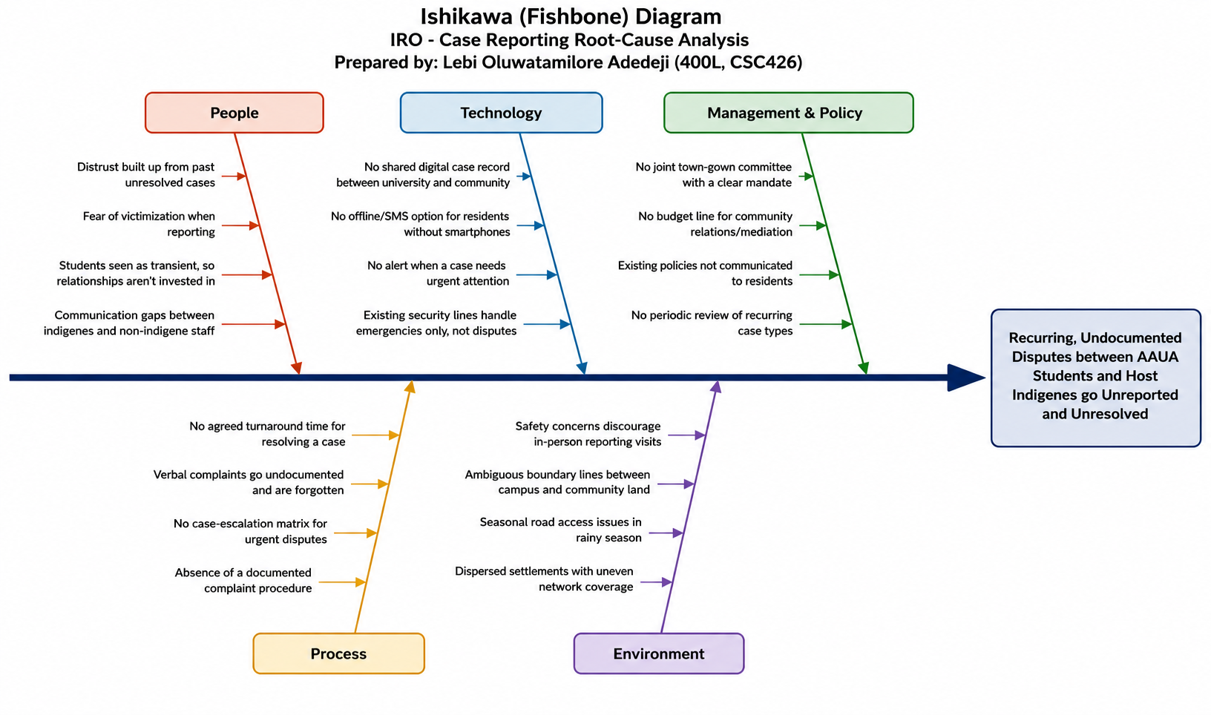

QUESTION 3: Mini web interface
Please check attached the Lebi_IRO_app.html file
QUESTION 4: Use-case diagram
A. Actors
- Student
- Indigene (Community Member)
- Case Officer
- Community/University Mediator
- Case Alert Service

B. Student / Indigene Use Cases
- Create Account / Sign In
- Open New Case
- Check Case Status
- View My Case History

C. Use Case
- Register
- Login
- Submit Report
- Upload Image
- Track Report
- View Feedback
- Manage Users
- Update Status
- Generate Report
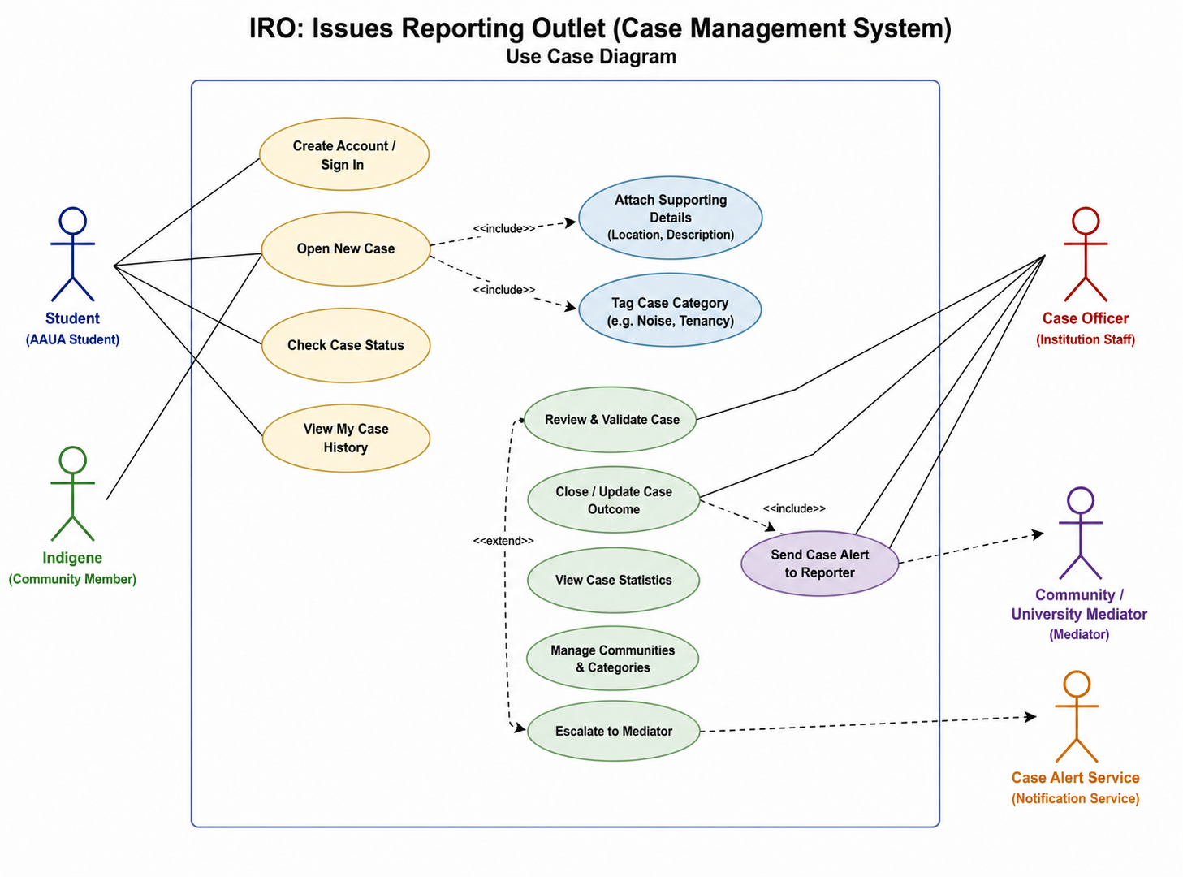

QUESTION 5: SRS (Software Requirement Specification) document
Please check attached the IRO_Software_Requirements_Specification.doc file

